**Report on**

**“Online Laptop Shop”**

SUBMITTED TO

**Darshan University - Rajkot**

IN FULFILLMENT OF THE REQUIREMENTS FOR THE AWARD OF

**DIPLOMA IN**

**COMPUTER ENGINEERING**

SUBMITTED BY

|  |  |
| --- | --- |
| **Student Name** | **Enrollment Number** |
| Arman F. Khorajiya | 23020201091 |
| Mahammadnazil M. Mathakiya | 23020201106 |
|  |  |
|  |  |

**GUIDED BY**

**Prof. Aadhyashree B. Pandya**



**September – 2025**

**DEPARTMENT OF COMPUTER ENGINEERING**

**DARSHAN INSTITUTE OF ENGG. & TECHNOLOGY FOR DIPLOMA STUDIES**

**RAJKOT-MORBI HIGHWAY, RAJKOT, GUJARAT**

**CERTIFICATE**

****This is to certify that **Arman F. Khorajiya (23020201091)** astudent of the Computer Engineering Department from Darshan University - Rajkot, has satisfactorily completed his project work on **“Online Laptop Shop”** in a group consisting of **TWO** persons under the guidance of **Prof.Aadhyashree B. Pandya.**

|  |  |
| --- | --- |
| **Internal Guide**  **(Prof.Aadhyashree B. Pandya)** | **Head of Department**  **(Prof.Chintan N. Kanani)** |

**CERTIFICATE**

This is to certify that **Mahammadnazil M. Mathakiya (23020201106)** astudent of the Computer Engineering Department from Darshan University - Rajkot, has satisfactorily completed his project work on **“Online Laptop Shop”** in a group consisting of **TWO** persons under the guidance of **Prof.Aadhyashree B. Pandya**



|  |  |
| --- | --- |
| **Internal Guide**  **(Prof.Aadhyashree B. Pandya)** | **Head of Department**  **(Prof.Chintan N. Kanani)** |

**EXAMINER’S CERTIFICATE OF APPROVAL**

This is to certify that project report entitled **Online Laptop Shop**

|  |  |
| --- | --- |
| **Student Name** | **Enrollment Number** |
| Arman F. Khorajiya | 23020201091 |
| Mahammadnazil M. Mathakiya | 23020201106 |
|  |  |
|  |  |

In Fulfillment for the award of the diploma in **“Computer Engineering”** of the Darshan University Rajkot is hereby approved.

|  |  |
| --- | --- |
| **Signature of**  **External Examiner** | **Signature of**  **Internal Examiner** |



**September – 2025**

**DEPARTMENT OF COMPUTER ENGINEERING**

**DARSHAN INSTITUTE OF ENGG. & TECHNOLOGY FOR DIPLOMA STUDIES**

**RAJKOT-MORBI HIGHWAY, RAJKOT, GUJARAT**

**ACKNOWLEDGEMENT**

First of all, we thank the almighty for providing us strength and courage to present the project. We avail this opportunity to express our sincere gratitude towards **Prof. Chintan N. Kanani,** **Head of Computer Engineering Department** for permitting us to conduct the project.

We express our cavernous sense of obligation and gratitude to our Guide **Prof. Aadhyashree B. Pandya** for her genuine guidance and constant encouragement throughout this project work. We are highly obliged to our honorable guide for providing us with such an opportunity to carry out research work under her continuous guidance.

Also, we are very thankful to Darshan University Computer Department faculties who supported us in getting our website ready. We also wish to express our heartfelt appreciation to our family, colleagues and many who have rendered their support for the successful works towards the completion of the research work, both explicitly and implicitly.

We also thank to our friends who suggested right way for the improvement of our project, they gave us complete support for the construction of our project according to guideline. We deeply acknowledge mutually to all project supporter for their never-ending encouragement, moral support and patience during the preparation of this project.

|  |  |
| --- | --- |
| **Student Name** | **Enrollment Number** |
| Arman F. Khorajiya | 23020201091 |
| Mahammadnazil M. Mathakiya | 23020201106 |
|  |  |
|  |  |

**ABSTRACT**

**Online Laptop Shop** Present a Laptop Ecommerce website as a modern platform for buying laptop. This project implement concept such as session handling for validation and database integration to build dynamic web application. The system offers to our customers to best convenience, competitive price and wide selection of laptop. This project presents a simplified online laptop shop developed using PHP & MYSQL, designed specifically for educational purpose using basic CRUD operation. User can login and, the system allows they can buy laptop as per their choice and they will track their order updates. And admin will check all their user, and also Manage all the product category wise. The User can give Feedback on product to Share their experience. This ensures Transparency and effectiveness of system between Users and Administrations.

|  |  |  |
| --- | --- | --- |
|  | **Table of Contents** |  |
| Certificate | | II |
| Acknowledgment | | V |
| Abstract | | VI |
| Table of Contents | | VII |
| Index | | VIII |
| List of Figures | | IX |
| List of Tables | | X |

**INDEX**

|  |  |  |  |
| --- | --- | --- | --- |
| **Chapter No.** | **Sub Chapter**  **No.** | **Content** | **Page No.** |
| 1 |  | **Introduction**…………………………………………... | 1 |
|  | 1.1 | Problem Summary……………………………………... | 1 |
| 2 |  | **Planning**……………………………………………….. | 2 |
|  | 2.1 | Model Description……………………………………... | 2 |
|  | 2.2 | Risk Management……………………………………… | 4 |
| 3 |  | **Detail Description**…………………………………….. | 7 |
| 4 |  | **Diagrams**……………………………………………… | 11 |
|  | 4.1 | Class Diagram…………………………………………. | 11 |
|  | 4.2 | Sequence Diagram……………………………………... | 12 |
|  | 4.3 | Collaboration Diagram………………………………… | 14 |
|  | 4.4 | State Diagram………………………………………….. | 16 |
|  | 4.5 | Activity Diagram………………………………………. | 19 |
|  | 4.6 | Use Case Diagram……………………………………... | 21 |
|  | 4.7 | Data Flow Diagram (Level 0)…………………………. | 22 |
|  |  | Data Flow Diagram (Level 1)…………………………. | 23 |
| 5 |  | **Data Dictionary**………………………………………. | 25 |
|  | 5.1 | E-R Diagram…………………………………………… | 28 |
| 6 |  | **Screen Shots**…………………………………………... | 29 |
| 7 |  | **Conclusion**…………………………………………….. | 44 |
| 8 |  | **Future Enhancement**…………………………………. | 45 |
| 9 |  | **Reference**……………………………………………… | 46 |

**List of Figures**

|  |  |  |
| --- | --- | --- |
| **Figure No.** | **Description of Figure** | **Page No.** |
| Fig 2.1 | Iterative Waterfall Model | 2 |
| Fig 4.2.1 | Sequence Diagram for Admin | 12 |
| Fig 4.2.2 | Sequence Diagram for User | 13 |
| Fig 4.3.1 | Collaboration Diagram for Admin | 14 |
| Fig 4.3.2 | Collaboration Diagram for User | 15 |
| Fig 4.4.1 | State Diagram of Order for Admin | 16 |
| Fig 4.4.2  Fig 4.4.3 | State Diagram of Product for Admin  State Diagram of Cart for Admin | 17  18 |
| Fig 4.5.1 | Activity Diagram for Admin | 19 |
| Fig 4.5.2 | Activity Diagram for User | 20 |
| Fig 4.6 | Use Case Diagram | 21 |
| Fig 4.7.1 | Data Flow Diagram level-0 | 22 |
| Fig 4.7.2 | Data Flow Diagram level-1 for Admin | 23 |
| Fig 4.7.3 | Data Flow Diagram level-1 for User | 24 |
| Fig 5.2  Fig 6.1  Fig 6.2  Fig 6.3  Fig 6.4  Fig 6.5  Fig 6.6  Fig 6.7  Fig 6.8  Fig 6.9  Fig 6.10  Fig 6.11  Fig 6.12  Fig 6.13  Fig 6.14  Fig 6.15 | ER Diagram  Home Screen  Shop Screen  Cart Screen  Profile Screen  Edit Profile Screen  Your Order Screen  View Order Details Screen  Dashboard Screen  Revenue Screen  Admin Profile Screen  Total Order Screen  Total User Screen  Total Product Screen  Total Review Screen  Meet our Team Screen | 28  29  30  31  32  33  34  35  36  37  38  39  40  41  42  43 |

**List of Tables**

|  |  |  |
| --- | --- | --- |
| **Table No.** | **Table Description** | **Page No.** |
| Table 5.1 | Admin_master | 25 |
| Table 5.2 | User_master | 25 |
| Table 5.3 | Brand_master | 25 |
| Table 5.4 | Product_master | 25 |
| Table 5.5 | Product_images | 26 |
| Table 5.6 | Cart_master | 26 |
| Table 5.6 | Order_master | 26 |
| Table 5.6 | Order_items | 27 |
| Table 5.6 | Review_master | 27 |

|  |
| --- |
| 1. **INTRODUCTION** |
|  |
| **1.1 PROBLEM SUMMARY** |
|  |
| * + 1. ***Problem Identification***   Buying a laptop from a physical store can be difficult and inconvenient for many people. In some areas, especially small towns or remote locations, there are limited stores and fewer laptop options available. Customers often don’t get enough information about different models, features, and prices when shopping in person. Visiting multiple stores take effort and time which is not ideal for busy people like students or working professionals. In some cases, the customer support in stores may also be limited, making it hard for people to choose the right laptop for their needs. |
|  |
| * + 1. ***Problem Solution***   An online laptop shop can help solve these problems by offering a wide variety of laptops from different brands in one place. The solution allows users to easily view full product details, view features and prices, read customer reviews, and make better buying decisions. Online shopping also saves time and energy since users can order from anywhere at any time with easy User interface. Overall, an online laptop shop provides a faster, easier, and more convenient efficient and user-friendly platform to shop for laptops. |

|  |
| --- |
| 1. **PLANNING** |
|  |
| **2.1 MODEL DESCRIPTION** |
| Feasibility study  Requirement analysis and specification  Design  Maintenance  Integration and system testing  Coding and unit testing |
| **Fig 2.1 Iterative Waterfall Model**   * In our project we are using iterative waterfall model. * It is not possible to strictly follow the classical waterfall model. * Making necessary changes to the classical waterfall model so that it becomes applicable to practical software development projects. * The main change to the classical waterfall model is in the form of providing feedback paths from every phase to its preceding phases as shown in figure. * The feedback paths allow for correction of the errors committed during a phase as and when these are detected in a later phase. * For example, if during testing a design error is identified then the feedback path allows the design to be reworked and the changes to be reflected in the design document. * There is no feedback path to the feasibility stage. This means that the feasibility study errors cannot be corrected.   **Requirements analysis and specification**   * The aim of the requirements analysis and specification phase is to understand the exact requirements of the customer and to document them properly. This phase consists of two distinct activities, namely * Requirements gathering and analysis, and * Requirements specification * The goal of the requirement’s gathering activity is to collect all relevant information from the customer regarding the product to be developed. This is done to clearly understand the customer requirements so that incompleteness and inconsistencies are removed. * The requirements analysis activity is begun by collecting all relevant data regarding the product to be developed from the users of the product and from the customer through interviews and discussions. * During SRS activity, the user requirements are systematically organized into a Software Requirements Specification (SRS) document.   **Design**   * During the design phase the software architecture is derived from the SRS document. Two distinctly different approaches are available. * Traditional design consists of two different activities; first a structured analysis of the requirements specification is carried out where the detailed structure of the problem is examined. During structured design, the results of structured analysis are transformed into the software design.   **Coding and unit testing (Implementation)**   * The purpose of the coding and unit testing phase of software development is to translate the software design into source code. Each component of the design is implemented as a program module. The end-product of this phase is a set of program modules that have been individually tested. * Each module is unit tested for determine the correct working of all the individual modules.   **Integration and system testing**   * Integration of different modules is done once they have been coded and unit tested. During the integration and system testing phase, the modules are integrated in a planned manner. * Finally, when all the modules have been successfully integrated and tested, system testing is carried out. The goal of system testing is to ensure that the developed system conforms to its requirements laid out in the SRS document. System testing usually consists of three different kinds of testing activities. * α – testing: It is the system testing performed by the development team. * β – Testing: It is the system testing performed by a friendly set of customers. * Acceptance testing: It is the system testing performed by the customer himself after the product delivery to determine whether to accept or reject the delivered product.   **Maintenance**   * Maintenance involves performing any one or more of the following three kinds of activities: * Correcting errors that were not discovered during the product development phase. This is called corrective maintenance. * Improving the implementation of the system, and enhancing the functionalities of the system according to the customer’s requirements. This is called perfective maintenance. * Porting the software to work in a new environment. For example, porting may be required to get the software to work on a new computer platform or with a new operating system. This is called adaptive maintenance. |
| **2.2 Risk Management**   * The aim of risk management is to reducing the impact of all kind of risks that might affect a project. Risk management consists of three essential activities: risk identification, risk assessment, and risk containment.   **Risk Identification**   * A software project can be affected by a large variety of risks. In order to be able to systematically identify the important risks which might affect a software project, it is necessary to categorize risks into different classes. * The project manager can then examine which risks from each class are relevant to the project. There are three main categories of risks which can affect a software project:   **Project Risks**   * Project risks concern varies forms of budgetary, schedule, personnel, resource, and customer-related problems. An important project risk is schedule. It is very difficult to monitor and control a software project. * It is very difficult to control something which cannot be seen. * The invisibility of the product being developed is an important reason for many software projects failure. * So in our project we are trying to resolve this kind of project risk which is also known as schedule risk.   **Technical Risks**   * Technical risks concern design, implementation, interfacing, testing, and maintenance problems. * Technical risks also include ambiguous specification, incomplete specification, changing specification, technical uncertainty. Most technical risks occur due to the team member’s insufficient knowledge about the project. * So in order to prevent this risk, we have done appropriate project analysis before starting our project.   **Business Risks**   * This type of risks include risks of building an excellent product that no one wants, losing budgetary or personnel commitments, etc.   **Risk Assessment**   * Risk assessment involves identifying risk, analyzing them and then assigns priority to them on the basis of the analysis. * The objective of risk assessment is to rank the risks in terms of their damage. For risk assessment, first each risk should be rated in two ways: * The probability of a risk coming true (denoted as r). * The result of the problems associated with that risk (denoted as s). * Based on these two factors, the priority of each risk can be computed:   **p = r * s**   * Where, p is the priority with which the risk must be handled, r is the probability of the risk becoming true, and so is the result of damage caused due to the risk becoming true. If all identified risks are prioritized, then the most likely and damaging risks can be handled first and reject procedures can be designed for these risks.   **Risk Containment**   * After all the identified risks of a project are assessed, plans must be made to containment the most damaging and the most likely risks. * Different risks require different containment procedures. In fact, most risks require expertness on the part of the project manager in handling the risk. * There are three main strategies to plan for risk containment: * **Avoid the risk:** This may take several forms such as discussing with the customer to change the requirements to reduce the scope of the work. * **Transfer the risk:** This strategy involves getting the risky component developed by a third party. * **Risk reduction:** This involves planning ways to containment the damage due to a risk. * To choose between the different strategies of handling a risk, the project manager must consider the cost of handling the risk and the corresponding reduction in risk. * For this we may compute the risk leverage of the different risks. Risk leverage is the difference in risk divided by the cost of reducing the risk. * **Risk leverage = (Risk before reducing - Risk after reducing) / cost of reducing** |

|  |
| --- |
| 1. **DETAIL DESCRIPTION** |
| **Admin_master** |
| The “Admin_master” table is designed to store information about administrators in the system. It contains essential details such as the administrator’s name, email, password, and mobile number. This table ensures that admin users can securely log in and manage the platform effectively. |
| * **Admin_id**: - Unique identifier for admin. * **Admin_name**: - Name of the admin. * **Admin_email**: - Email address of the admin. * **Admin_password: -** Password used for authentication. * **Admin_mobile_no**: - Contact number of the admin. |
| **User_master** |
| The “User_master” table contains all information about registered users. It supports login, profile management, and links users to their orders, reviews, and carts. Users can search and filter products as per their requirements. The design should take into account data privacy and security consideration to protect user information and ensure regulatory compliance, especially dealing with sensitive data like Mobile no and Email ID using validations. |

* **user_id: -** Unique identifier for user.
* **full_name: -** Full name of user.
* **user_email: -** Email of user.
* **user_password: -** Password for authentication.
* **user_mobile_no: -** Contact number.
* **created_at: -** Account creation date and time.
* **user_address: -** User address.

|  |
| --- |
| **Brand_master** |
| The “Brand_master” table manages details of product brands available in the system. It helps organize products by brand, making it easier for users to search and filter products.   * **brand_id: -** Unique identifier for the brand. * **brand_name: -** Name of the brand. * **brand_status: -** Current status of the brand (Active, Inactive). |
| **Product_master** |
| The “Product_master” table stores detailed information about each product available in the system. It covers name, description, brand, price, stock, and images. The product manage in the system is particular brand wise. |
| * **product_id: -** Unique identifier for product. * **product_name: -** Name of the product. * **product_description: -** Product description. * **brand_id: -** Each Product associate with specific brand. * **product_price: -** Product price. * **stock quantity: -** Quantity in stock. * **added_at: -** Date added. * **image_path: -** Primary/default image path.   **Product_images**  The “Product_images” table manages multiple images for products, allowing better product visualization for customers.   * **image_id: -** Unique image identifier. * **product_id: -** Associated product. * **image_path: -** File path/URL of product image.   **Cart_master**  The “Cart_master” table stores information about items added to each user’s shopping cart. It connects users with products and manages quantities until an order is placed.   * **cart_id: -** Unique identifier for each cart entry. * **user_id: -** User who owns the cart. * **product_id: -** Product added to the cart. * **quantity: -** Number of units added. * **added_at: -** Date and time when product was added.   **Order_master**  The “Order_master” table stores complete order details placed by customers. It includes unique order identification, customer reference, payment information, delivery address, and item quantity details. This table also maintains order status, total amount, and order date, serving as the primary record for all transactions and ensuring proper tracking, communication, and fulfillment of customer orders.   * **order_id: -** Unique identifier for the order. * **user_id: -** Customer reference. * **total_amount: -** Total order amount. * **order_status: -** Current order status. * **order_date: -** Order placement date. * **delivery_address: -** Orderdelivery address. * **payment_mode: -** Payment method. * **full_name: -** Customer’s full name. * **user_email: -** Customer’s email. * **user_mobile_no: -** Customer’s mobile number. * **total_quantity: -** Total quantity of items.   **Order_Items**  The “Order_items” table stores details of products associated with each order. It keeps track of purchased products, their references, and quantities. Each entry links an order to specific products through order and product IDs. This ensures accurate billing, inventory management, and order fulfillment.   * **order_item_id: -** Unique identifier for order item. * **order_id: -** Reference to the order. * **product_id: -** Reference to product purchased. * **quantity: -** Number of units purchased.   **Review_master**  The “Review_master” table stores customer reviews and ratings for products. It helps track customer satisfaction and provide feedback to future buyers. These reviews are shown by Admin to improve efficiency of website accordingly.   * **review_id: -** Unique review identifier. * **user_id: -** Stores User ID who give review. * **product_id: -** Product ID on which user can give review. * **rating: -** Rating given to product. * **comment: -** Review/feedback comment. * **review_date: -** Review submission date and time. |
| 1. **DIAGRAMS** | |
| **4.1 CLASS DIAGRAM** | |
|  | |
| **Fig 4.1 Class Diagram of Online Laptop Shop** | |
| **4.2 SEQUENCE DIAGRAM**  ***4.2.1 SEQUENCE DIAGRAM FOR ADMIN***    **Fig 4.2.1 Sequence Diagram for Admin of Online Laptop Shop**  ***4.2.2 SEQUENCE DIAGRAM FOR USER***    **Fig 4.2.2 Sequence Diagram for User of Online Laptop Shop**  **4.3 COLLABORATION DIAGRAM**  ***4.3.1 COLLABORATION DIAGRAM FOR ADMIN***      **Fig 4.3.1 Collaboration Diagram for Admin of Online Laptop Shop**    ***4.3.2 COLLABORATION DIAGRAM FOR USER***    **Fig 4.3.2 Collaboration Diagram for User of Online Laptop Shop**  **4.4 STATE DIAGRAM**  ***4.4.1 STATE DIAGRAM OF ORDER FOR ADMIN***    **Fig 4.4.1 State Diagram for Order of Online Laptop Shop**  ***4.4.2 STATE DIAGRAM OF PRODUCT FOR ADMIN***      **Fig 4.4.2 State Diagram for Product of Online Laptop Shop**    ***4.4.3 STATE DIAGRAM OF CART FOR ADMIN***    **Fig 4.4.3 State Diagram for Cart of Online Laptop Shop**  **4.5 ACTIVITY DIAGRAM**  ***4.5.1 ACTIVITY DIAGRAM FOR ADMIN***    **Fig 4.5.1 Activity Diagram for Admin of Online Laptop Shop**    ***4.5.2 ACTIVITY DIAGRAM FOR USER***      **Fig 4.5.2 Activity Diagram for User of Online Laptop Shop**  **4.6 USE CASE DIAGRAM**    **Fig 4.6 Use case Diagram of Online Laptop Shop**   * 1. **DATA FLOW DIAGRAM**   ***4.7.1 DATA FLOW DIAGRAM LEVEL 0***    **Fig 4.7.1 Data Flow Diagram Level 0 of Online Laptop Shop**  ***4.7.2 DATA FLOW DIAGRAM LEVEL 1 FOR ADMIN***    **Fig 4.7.2 Data Flow Diagram for Level 1 for Admin of Online Laptop Shop**  ***4.7.3 DATA FLOW DIAGRAM LEVEL 1 FOR USER***    **Fig 4.7.3 Data Flow Diagram for Level 1 for User of Online Laptop Shop** | |
| 1. **DATA DICTIONARY** | |
| **5.1 DATABASE TABLES**  **Table 1.1: Admin_master** | |
| |  |  |  |  |  | | --- | --- | --- | --- | --- | | **Field Name** | **Data Type** | **Size** | **Constraint** | **Reference** | | admin_id | int | 10 | PRIMARY KEY, AUTO_INCREMENT | - | | admin_name | varchar | 100 | NOT NULL | - | | admin_email | varchar | 150 | NOT NULL | - | | admin_password | varchar | 10 | NOT NULL | - | | admin_mobile_no | bigint | 12 | NOT NULL | - | | |
| **Table 1.2: User_master**   |  |  |  |  |  | | --- | --- | --- | --- | --- | | **Field Name** | **Data Type** | **Size** | **Constraint** | **Reference** | | user_id | int | 10 | PRIMARY KEY, AUTO_INCREMENT | - | | full_name | varchar | 150 | NOT NULL | - | | user_email | varchar | 100 | UNIQUE, NOT NULL | - | | user_password | int | 10 | NOT NULL | - | | user_mobile_no | bigint | 20 | NOT NULL | - | | created_at | timestamp | - | DEFAULT CURRENT_TIMESTAMP | - | | user_address | text | - | NOT NULL | - |   **Table 1.3: Brand_master**   |  |  |  |  |  | | --- | --- | --- | --- | --- | | **Field Name** | **Data Type** | **Size** | **Constraint** | **Reference** | | brand_id | int | 11 | PRIMARY KEY, AUTO_INCREMENT | - | | brand_name | varchar | 100 | UNIQUE, NOT NULL | - | | brand_status | Enum ('active’, ‘inactive') | 255 | NOT NULL | - | | |
|  | |
| **Table 1.4: Product_master**   |  |  |  |  |  | | --- | --- | --- | --- | --- | | **Field Name** | **Data Type** | **Size** | **Constraint** | **Reference** | | product_id | int | 11 | PRIMARY KEY, AUTO_INCREMENT | - | | product_name | varchar | 150 | NOT NULL | - | | product_description | text | - | NOT NULL | - | | brand_id | int | 11 | FOREIGN KEY | Brand_master →brand_id | | product_price | decimal | 10,2 | NOT NULL | - | | stock_quantity | int | 11 | NOT NULL | - | | added_at | datetime | - | DEFAULT CURRENT_TIMESTAMP | - | | image_path | varchar | 255 | - | - |     **Table 1.5: Product_images**   |  |  |  |  |  | | --- | --- | --- | --- | --- | | **Field Name** | **Data Type** | **Size** | **Constraint** | **Reference** | | image_id | int | 11 | PRIMARY KEY, AUTO_INCREMENT | - | | product_id | int | 11 | FOREIGN KEY | product_master→ product_id | | image_path | varchar | 255 | NOT NULL | - |   **Table 1.6: Cart_master**   |  |  |  |  |  | | --- | --- | --- | --- | --- | | **Field Name** | **Data Type** | **Size** | **Constraint** | **Reference** | | cart_id | int | 11 | PRIMARY KEY, AUTO_INCREMENT | - | | user_id | int | 11 | FOREIGN KEY | user_master→ user_id | | product_id | int | 11 | FOREIGN KEY | product_master→ product_id | | quantity | int | 11 | NOT NULL, CHECK > 0 | - | | added_at | datetime | - | DEFAULT CURRENT_TIMESTAMP | - |   **Table 1.7: Order_master**   |  |  |  |  |  | | --- | --- | --- | --- | --- | | **Field Name** | **Data Type** | **Size** | **Constraint** | **Reference** | | order_id | int | 11 | PRIMARY KEY, AUTO_INCREMENT | - | | user_id | int | 11 | FOREIGN KEY | user_master→ user_id | | total_amount | decimal | 10,2 | NOT NULL | - | | order_status | varchar | 50 | ENUM | - | | order_date | datetime | - | DEFAULT CURRENT_TIMESTAMP | - | | delivery_address | varchar | 255 | - | - | | Payment_mode | varchar | 20 | - | - | | Full_name | text |  | NOT NULL | - | | User_email | varchar | 100 | NOT NULL | - | | User_mobile_no | bigint | 12 | NOT NULL | - | | Total_quantity | int | 11 | - | - |     **Table 1.8: Order_items**   |  |  |  |  |  | | --- | --- | --- | --- | --- | | **Field Name** | **Data Type** | **Size** | **Constraint** | **Reference** | | order_item_id | int | 11 | PRIMARY KEY, AUTO_INCREMENT | - | | order_id | int | 11 | FOREIGN KEY | order_master→ order_id | | product_id | int | 11 | - | - | | quantity | int | 11 | - | - |   **Table 1.9: Review_master**   |  |  |  |  |  | | --- | --- | --- | --- | --- | | **Field Name** | **Data Type** | **Size** | **Constraint** | **Reference** | | review_id | int | 11 | PRIMARY KEY, AUTO_INCREMENT | - | | user_id | int | 11 | NOT NULL | - | | product_id | int | 11 | NOT NULL | - | | rating | int | 11 | NOT NULL | - | | comment | text | - | - | - | | review_date | timestamp | - | DEFAULT CURRENT_TIMESTAMP | - |   **5.2 ER DIAGRAM**    **Fig 5.2 ER Diagram of Online Shopping System**   |  | | --- | | 1. **SCREENSHOTS** |   **HOME SCREEN**      **Fig 6.1 Home Screen**   * This is Home Screen of site. * In this screen there is categorized data for top rated products, bestsellers and latest arrivals.   **SHOP SCREEN**    **Fig 6.2 Shop Screen**   * This is Shop Screen of site. * In this screen user can view different products with filter and also their account details. | |

**CART SCREEN**

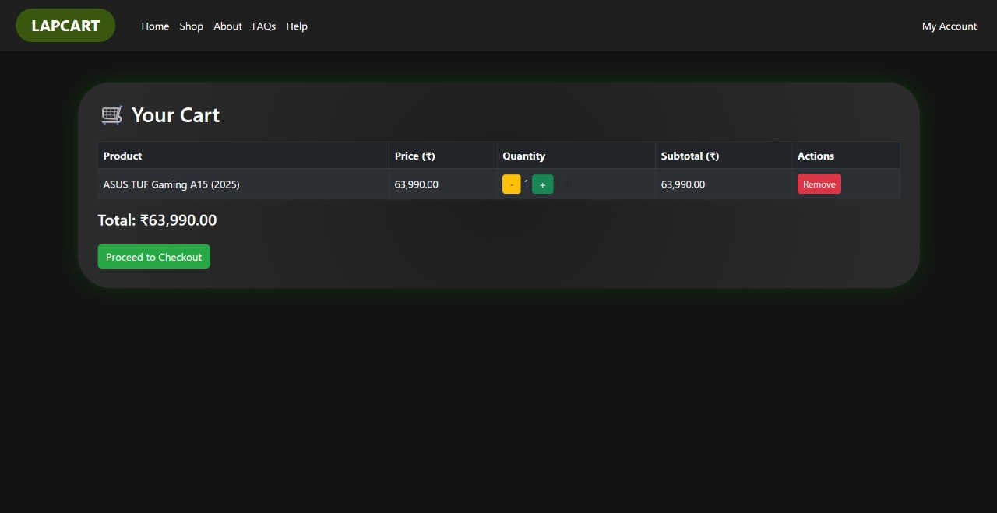

**Fig 6.3 Cart Screen**

* This is Cart Screen of site.
* User can Manage their cart in this screen.

**PROFILE SCREEN**

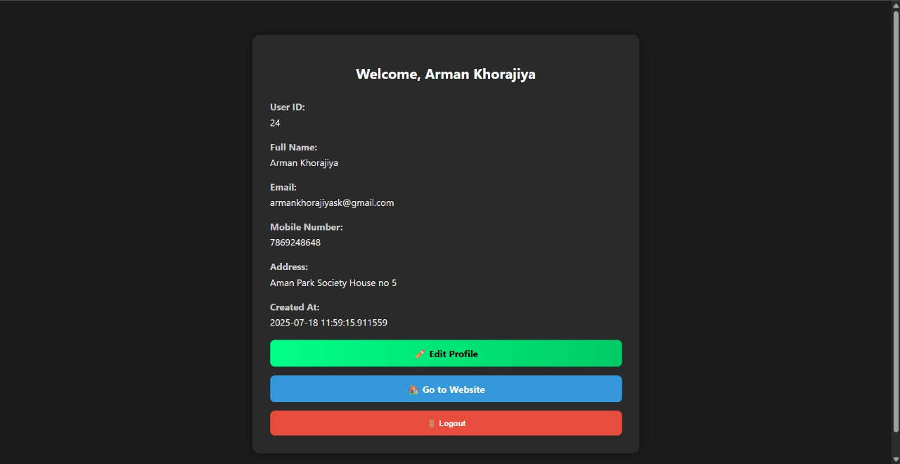

**Fig 6.4 Profile Screen**

* This is User Profile Screen of site.
* User able to view their profile info and also Option for profile edit and logout.

**EDIT PROFILE SCREEN**

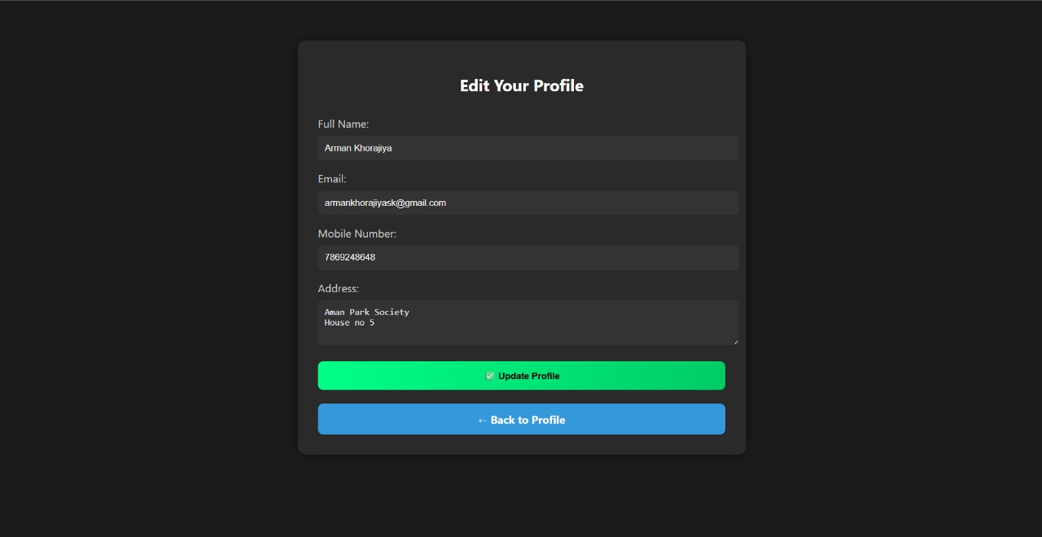

**Fig 6.5 Edit Profile Screen**

* This is Edit User Profile Screen of site.
* User can Edit their profile details in this screen.

**YOUR ORDER SCREEN**

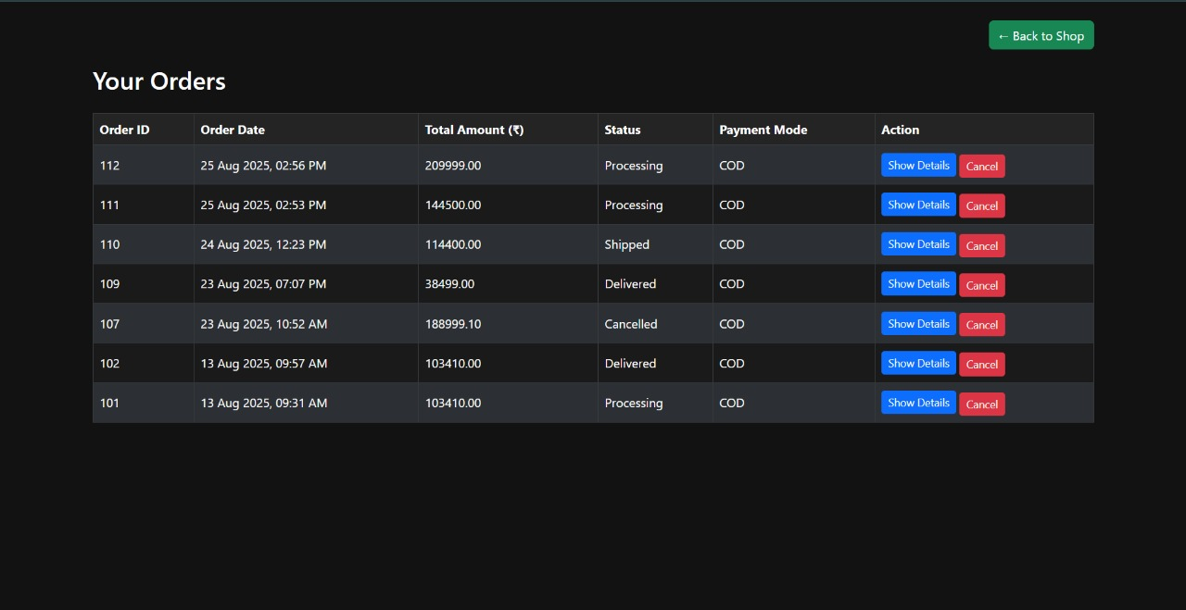

**Fig 6.6 Your Order Screen**

* This is Your Order Screen of site.
* User can view all his orders and option for Show order details and cancel the order.

**VIEW ORDER DETAILS SCREEN**

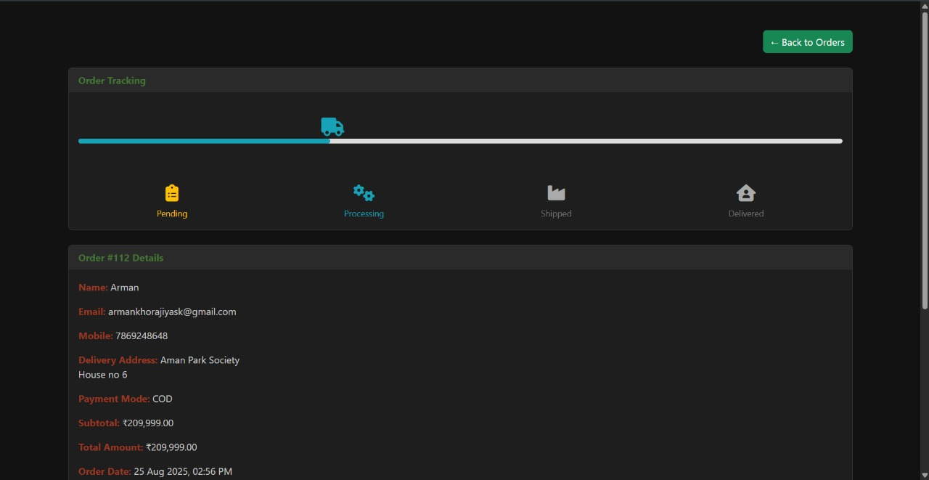

**Fig 6.7 View Order Details Screen**

* This is View Order Details Screen of site.
* In this screen user can view all the details related to their order.

**ADMIN DASHBOARD SCREEN**

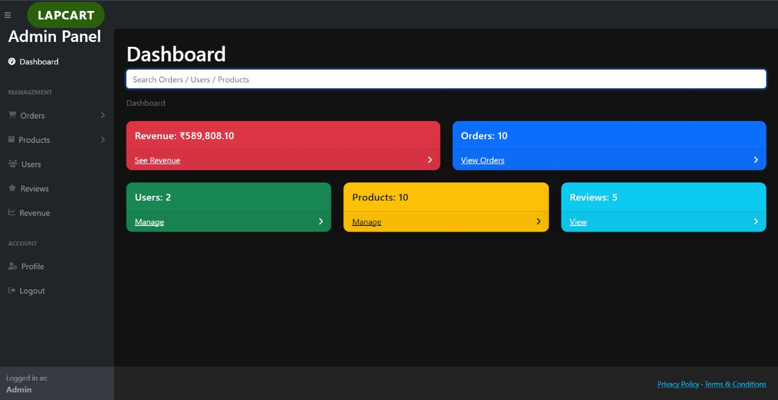

**Fig 6.8 Admin Dashboard Screen**

* This is Dashboard Screen of site.
* In this screen admin can view and manage all over the site.

**REVENUE SCREEN**

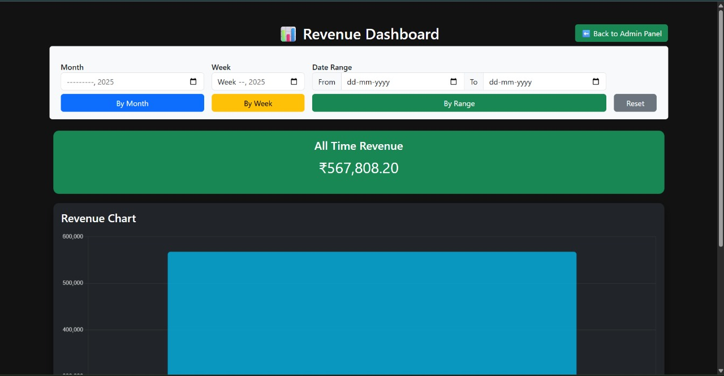

**Fig 6.9 Revenue Screen**

* This is Revenue Screen of site.
* In revenue screen admin can see Revenue of shop by month, week, and date range.

**ADMIN PROFILE SCREEN**

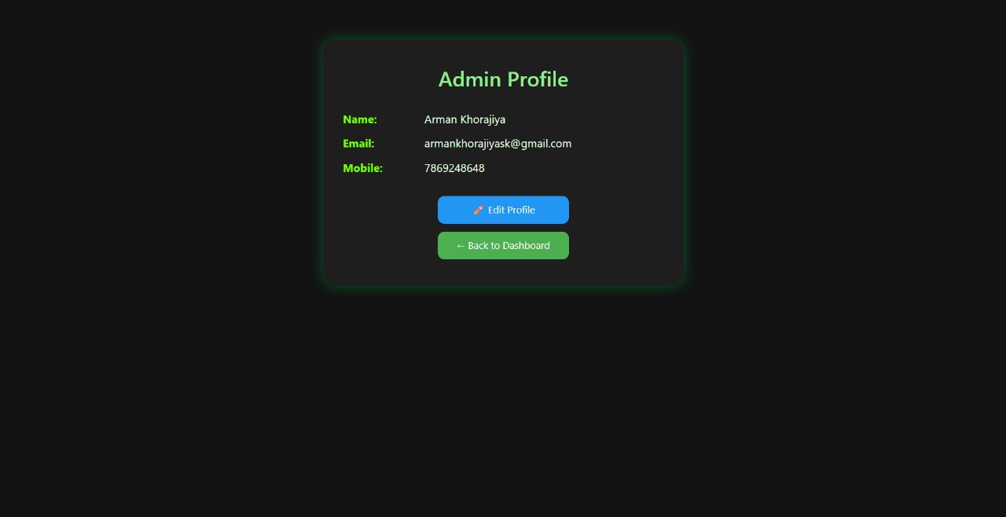

**Fig 6.10 Admin Profile Screen**

* This is Admin Profile Screen of site.
* Admin can view Info of their profile and option for Edit profile.

**TOTAL ORDERS SCREEN**

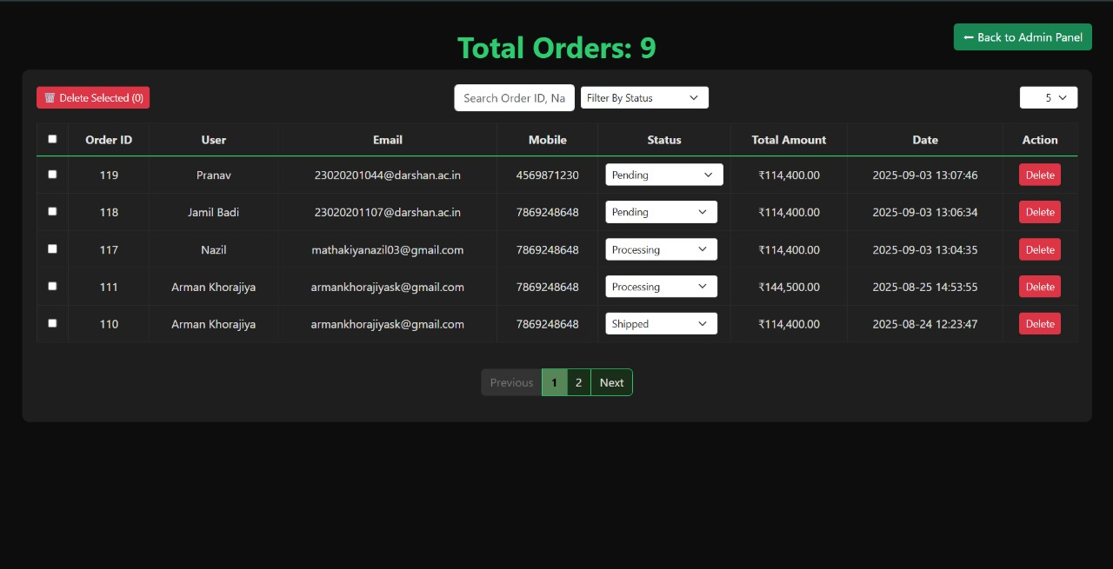

**Fig 6.11 Total Order Screen**

* This is Total Order Screen of site.
* Admin manage all their orders in this screen.

**TOTAL USERS SCREEN**

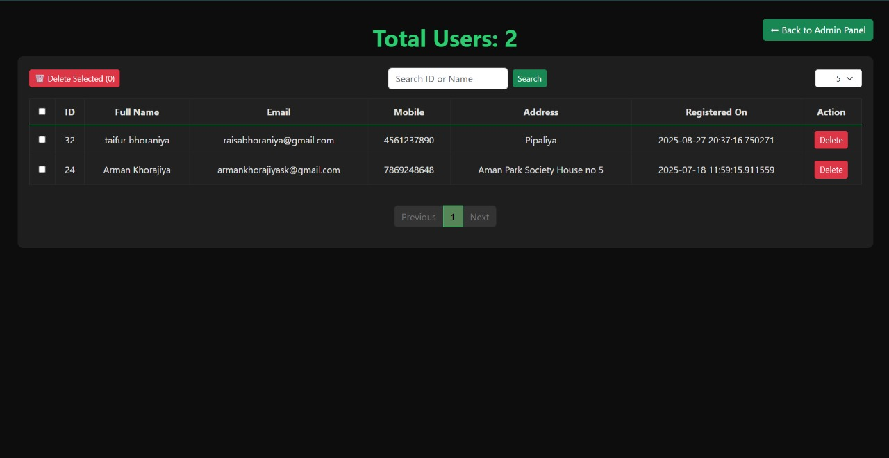

**Fig 6.12 Total Users Screen**

* This is Total Users Screen of site.
* Admin manage all their user in this screen.

**TOTAL PRODUCT SCREEN**

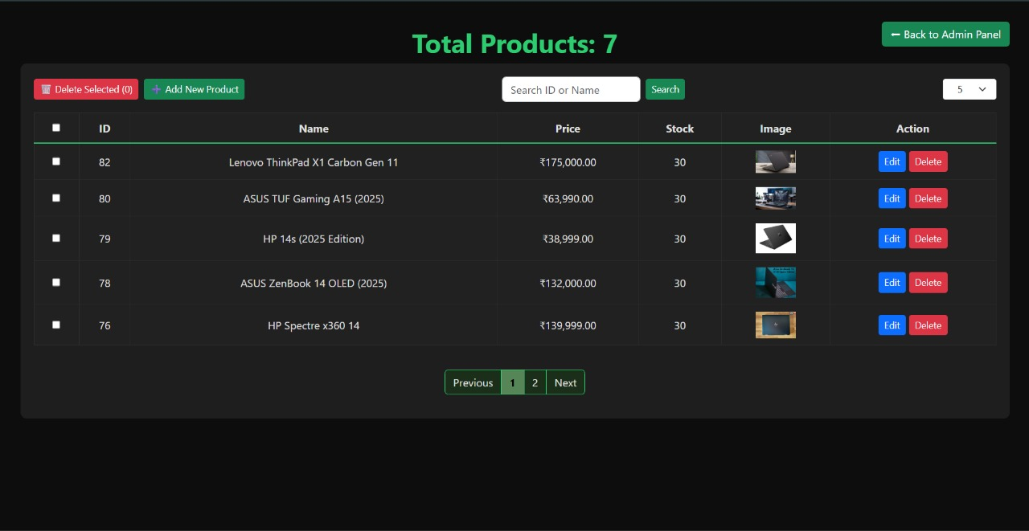

**Fig 6.13 Total Product Screen**

* This is Total Product Screen of site.
* Admin manage all their Product in this screen.

**TOTAL REVIEWS SCREEN**

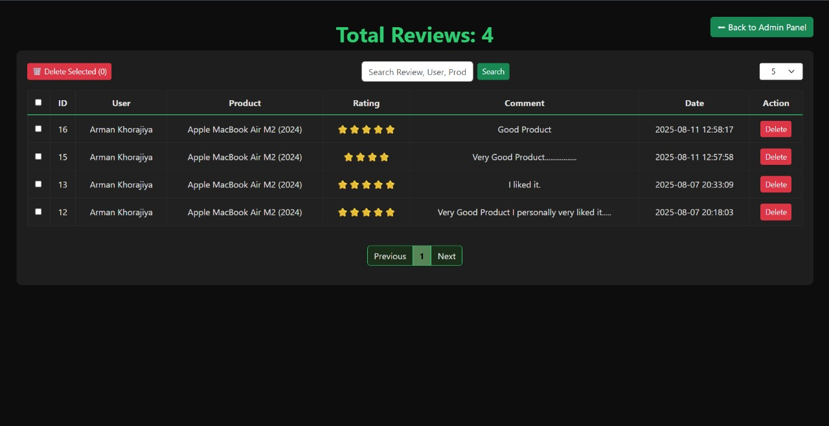

**Fig 6.14 Total Reviews Screen**

* This is Total Reviews Screen of site.
* Admin can View and also delete review from this screen.

**MEET OUR TEAM SCREEN**

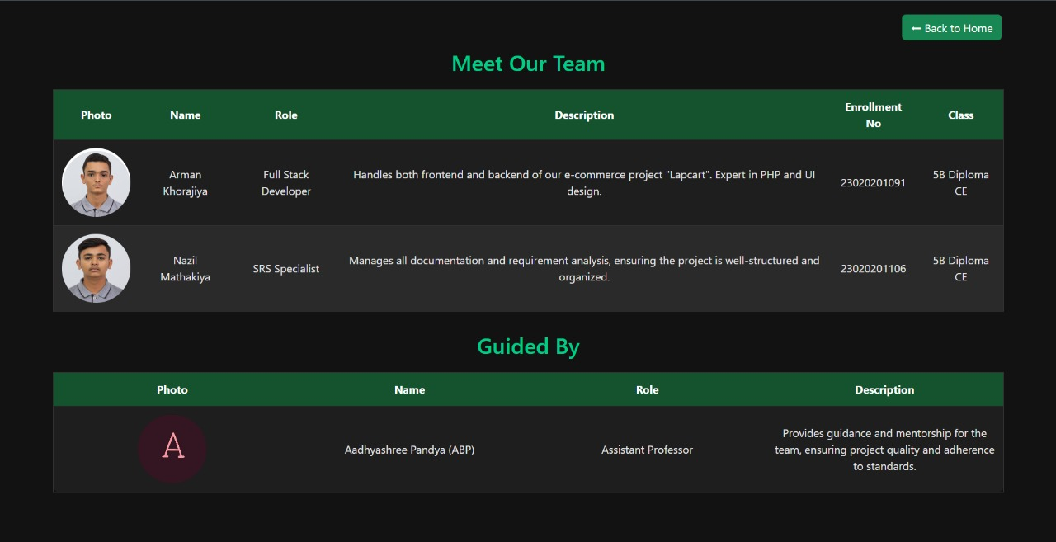

**Fig 6.15 Meet our Team Screen**

* This is Meet our Team Screen of site.
* In this screen there is details of our team and guide.

|  |
| --- |
| 1. **CONCLUSION** |
| The Online Laptop Shop system provides a modern and efficient platform for managing laptop sales and customer interactions. It reduces the need for manual processes by offering features such as product search, viewing detailed specifications, managing carts, and providing reviews and feedback. This system ensures a user-friendly experience for customers while also simplifying business operations for administrators. By digitizing the sales process, the system saves time, minimizes errors, and increases accessibility. Overall, the Online Laptop Shop successfully replaces traditional shopping methods with a convenient, reliable, and technology-driven solution for both buyers and sellers. |

|  |
| --- |
| 1. **FUTURE ENHANCMENT** |
| online laptop shop can include adding a sub-category feature under each main category. This will help users easily browse laptops based on brand, price range, specifications, or usage type. It will make product search more organized and convenient for customers. Overall, sub-categories will improve navigation and user experience in the shop. |

|  |
| --- |
| 1. **REFERENCES** |
| |  |  | | --- | --- | | **Description** | **Websites** | | GeeksforGeeks  W3Schools  Phppot  GitHub  ChatGPT  YouTube  Draw.io | <https://geeksforgeeks.org>  <https://www.w3schools.com>  <https://phppot.com>  <https://github.com>  <https://chatgpt.com>  <https://www.youtube.com>  <https://app.diagrams.net> | |  |  | |